Entrust Church History: The Disciples of the Apostles 11/19/20

“These things entrust to faithful men, who will be able to entrust others also”
-The Apostle Paul to Timothy, 2 Tim. 2:2

INTRODUCTORY NOTE: Although scholars do not always agree on the specific dates, the general consensus includes the following individuals as disciples of the Apostles: Clement of Rome, Ignatius of Antioch, Barnabas of Alexandria, Papias of Heiropolis, Polycarp of Smyrna, and the authors of The Didache, The Shepherd of Hermas, and The Letter to Diognetus. The early date of these Fathers and their writings is what makes them so significant. Outside of the New Testament itself, they furnish the earliest testimony of church life—echoing the initial understanding of apostolic teaching.

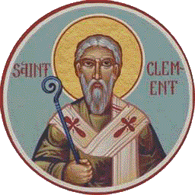
Clement of Rome (c. 30–d. 100)
- The fourth pastor at the church of Rome (from around 90–100); followed after Peter, Linus, and Cletus (according to Roman tradition)
- He was born before Christ died and died around the same time as the Apostle John
- Probably mentioned in Philippians 4:3; if so, then he was a coworker with Paul; probably mentioned also in Shepherd of Hermas
- A disciple of both Peter and Paul (from their time in Rome); according to tradition, martyred under Emperor Trajan
- He wrote a letter to the Corinthians around 95. This is generally considered to be the oldest Christian document we have outside of the New Testament. It was written while the apostle John was still alive.
  - That Clement wrote this letter is affirmed by Eusebius (Hist. Eccl., 3. 15), Origen (Comm. in Joan., 1. 29), and others.
  - Eusebius (Hist. Eccl., 3. 16) says this about this letter: “There is one acknowledged Epistle of this Clement [whom he has just identified with the friend of St. Paul], great and admirable, which he wrote in the name of the Church of Rome to the Church at Corinth, sedition having then arisen in the latter Church. We are aware that this Epistle has been publicly read in very many churches both in old times, and also in our own day.”
- Scholars generally agree that the Second Epistle of Clement was written later and is not his work.

Polycarp of Smyrna (c. 69–c. 155)
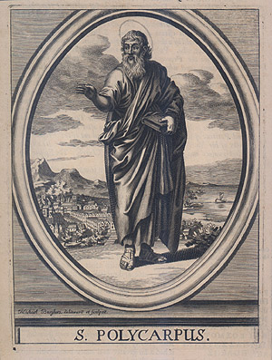
- Disciple of John; friend of Ignatius; companion of Papias; teacher of Irenaeus

- One extant letter, Letter to the Philippians

- Is a connecting link between first and second century

- Smyrna is mentioned in Rev. 2:8–13

- Stabbed to death at 86 years old and then his body burned at the stake; later writing entitled, The Martyrdom of Polycarp, details his death

According to this account:

- When he was found, he fed dinner to the Roman guards who had come to arrest him. He then asked for an hour in prayer, which they permitted him to have. Yet his prayer was so fervent and passionate that his captors regretted even being involved in his apprehension.

- Appearing before a Roman proconsul, Polycarp stood firm. The proconsul even urged him to deny Christ, “Swear, and I will release you—reproach Christ.”

- But Polycarp’s faith was undeterred: “Eighty and six years have I served Him, and He never once wronged me; how then shall I blaspheme my King, Who has saved me?” When it was clear that Polycarp would not recant, he was sentenced to be burned at the stake.

- Key Quote:

“I know that through grace you are saved, not of works, but by the will of God, through Jesus Christ.” (The Epistle of Philippians)

Ignatius of Antioch (d. between 98–117)

- Bishop of the church in Syrian Antioch; according to tradition, he was the third pastor in Antioch and was appointed by Peter himself to the position

- Wrote at least seven authentic letters to various churches; he was a disciple and contemporary of the Apostle John

- Killed as a martyr in Rome, in the Coliseum
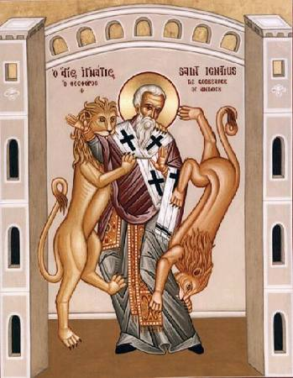
- Promoted single-bishop form of church government, and the replacement of the Sabbath with the Lord’s Day

- Key Quotes:
Regarding salvation: “His cross, and his death, and his resurrection, and the faith which is through him, are my unpolluted muniments; and in these, through your prayers, I am willing to be justified” (Epistle to Philadelphians).
Regarding the Lord’s Day: Be not seduced by strange doctrines nor by antiquated fables, which are profitless. For if even unto this day we live after the manner of Judaism, we avow that we have not received grace.... If then those who had walked in ancient practices attained unto newness of hope, no longer observing Sabbaths but fashioning their lives after the Lord's day, on which our life also arose through Him and through His death which some men deny ... how shall we be able to live apart from Him? ... It is monstrous to talk of Jesus Christ and to practise Judaism. For Christianity did not believe in Judaism, but Judaism in Christianity — Ignatius to the Magnesians 8:1, 9:1-2, 10:3, Lightfoot translation.
First to use the term “catholic” [katholikos or “universal”] church: Wherever the bishop appears, there let the people be; as wherever Jesus Christ is, there is the Catholic Church. It is not lawful to baptize or give communion without the consent of the bishop. On the other hand, whatever has his approval is pleasing to God. Thus, whatever is done will be safe and valid. — Letter to the Smyrnaeans 8, J.R. Willis translation.
Regarding martyrdom: I am writing to all the Churches and I enjoin all, that I am dying willingly for God's sake, if only you do not prevent it. I beg you, do not do me an untimely kindness. Allow me to be eaten by the beasts, which are my way of reaching to God. I am God's wheat, and I am to be ground by the teeth of wild beasts, so that I may become the pure bread of Christ.— Letter to the Romans

Papias (c. 60–c. 130)

- Wrote Interpretations of the Sayings of the Lord (now lost); only extant writings come from Irenaeus and Eusebius

- Was ridiculed by Eusebius for believing in a literal millennial kingdom

- Noted that Mark wrote his gospel from Peter; and that Matthew wrote his gospel in Hebrew

- Key Quotes:

On his relationship to John: I will not hesitate to add also for you to my interpretations what I formerly learned with care from the Presbyters and have carefully stored in memory, giving assurance of its truth. For I did not take pleasure as the many do in those who speak much, but in those who teach what is true, nor in those who relate foreign precepts, but in those who relate the precepts which were given by the Lord to the faith and came down from the Truth itself. And also if any follower of the Presbyters happened to come, I would inquire for the sayings of the Presbyters, what Andrew said, or what Peter said, or what Philip or what Thomas or James or what John or Matthew or any other of the Lord's disciples, and for the things which other of the Lord's disciples, and for the things which Aristion and the Presbyter John, the disciples of the Lord, were saying. For I considered that I should not get so much advantage from matter in books as from the voice which yet lives and remains.

On the writing of the Gospels: Mark having become the interpreter of Peter, wrote down accurately whatsoever he remembered. It was not, however, in exact order that he related the sayings or deeds of Christ. For he neither heard the Lord nor accompanied Him. But afterwards, as I said, he accompanied Peter, who accommodated his instructions to the necessities [of his hearers], but with no intention of giving a regular narrative of the Lord's sayings. Wherefore Mark made no mistake in thus writing some things as he remembered them. For of one thing he took especial care, not to omit anything he had heard, and not to put anything fictitious into the statements. Matthew put together the oracles [of the Lord] in the Hebrew language, and each one interpreted them as best he could.

On premillennialism (from Eusebius): The same person, moreover, has set down other things as coming to him from unwritten tradition, amongst these some strange parables and instructions of the Saviour, and some other things of a more fabulous nature. Amongst these he says that there will be a millennium after the resurrection from the dead, when the personal reign of Christ will be established on this earth.” (Exposition of the Oracles of the Lord - Fragment VI).

SELECT READINGS FROM THE APOSTOLIC FATHERS

* * * * *

The First Epistle of Clement to the Corinthians
(Translation by J. B. Lightfoot with English wording updated slightly)

Chapter 31

(1) Let us therefore cling to His blessing, and let us see what are the ways of blessing. Let us study the records of the things that have happened from the beginning.

(2) Why was our father Abraham blessed? Was it not because he wrought righteousness and truth through faith?

(3) Isaac with confidence, as knowing the future, was led as a willing sacrifice.

(4) Jacob with humility departed from his land because of his brother, and went to Laban and served; and the twelve tribes of Israel were given to him.

Chapter 32

(1) If any man will consider them one by one in sincerity, he shall understand the magnificence of the gifts that are given by Him.

(2) For of Jacob are all the priests and Levites who minister unto the altar of God; of him is the Lord Jesus as concerning the flesh; of him are kings and rulers and governors in the line of Judah; yea and the rest of his tribes are held in no small honor, seeing that God promised saying, Thy seed shall be as the stars of heaven.

(3) They all therefore were glorified and magnified, not through themselves or their own works or the righteous doing which they wrought, but through His will.

(4) And so we, having been called through His will in Christ Jesus, are not justified through ourselves or through our own wisdom or understanding or piety or works which we wrought in holiness of heart, but through faith, whereby the Almighty God justified all men that have been from the beginning; to whom be the glory forever and ever. Amen.

Chapter 33

(1) What then must we do, brethren? Must we idly abstain from doing good, and forsake love? May the Master never allow this to befall us at least; but let us hasten with urgency and zeal to accomplish every good work.

(2) For the Creator and Master of the universe Himself rejoices in His works.

(3) For by His exceeding great might He established the heavens, and in His incomprehensible wisdom He set them in order. And the earth He separated from the water that surrounds it, and He set it firm on the sure foundation of His own will; and the living creatures which walk upon it He commanded to exist by His ordinance. Having before created the sea and the living creatures therein, He enclosed it by His own power.

(4) Above all, as the most excellent and exceeding great work of His intelligence, with His sacred and faultless hands He formed man in the impress of His own image.

(5) For thus says God, Let us make man after our image and after our likeness. And God made man; male and female made He them.

(6) So having finished all these things, He praised them and blessed them and said, Increase and multiply.

(7) We have seen that all the righteous were adorned in good works. Yea, and the Lord Himself having adorned Himself with worlds rejoiced.

(8) Seeing then that we have this pattern, let us conform ourselves with all diligence to His will; let us with all our strength work the work of righteousness.

Chapter 34

(1) The good workman receives the bread of his work with boldness, but the slothful and careless dares not look his employer in the face.

(2) It is therefore needful that we should be zealous unto well doing, for of Him are all things:

(3) since He forewarns us saying, Behold, the Lord, and His reward is before His face, to recompense each man according to his work.

(4) He exhorts us therefore to believe on Him with our whole heart, and to be not idle nor careless unto every good work.

(5) Let our boast and our confidence be in Him: let us submit ourselves to His will; let us mark the whole host of His angels, how they stand by and minister unto His will.

(6) For the scripture says, Ten thousands of ten thousands stood by Him, and thousands of thousands ministered unto Him: and they cried aloud, Holy, holy, holy is the Lord of hosts; all creation is full of His glory.

(7) Yea, and let us ourselves then, being gathered together in unity with intentness of heart, cry unto Him as from one mouth earnestly that we may be made partakers of His great and glorious promises.

(8) For He says, Eye has not seen and ear has not heard, and it has not entered into the heart of man what great things He has prepared for them that patiently await Him.

Chapter 35

(1) How blessed and marvelous are the gifts of God, dearly beloved!!

(2) Life in immortality, splendor in righteousness, truth in boldness, faith in confidence, temperance in sanctification! And all these things fall under our apprehension.

(3) What then, do you think, are the things being prepared for them that patiently await Him? The Creator and Father of the ages, the All holy One Himself knows their number and their beauty.

(4) Let us therefore contend, that we may be found in the number of those that patiently await Him, to the end that we may be partakers of His promised gifts.

* * * * *

The Shepherd of Hermas

(Translation by Roberts and Donaldson with English wording updated slightly)

- The Shepherd of Hermas was written mid-second century. Some scholars categorize it with the apocalypses of NT apocrypha, because it is apocalyptic in style and full of allegory and symbolism.

FOURTH VISION
CONCERNING THE TRIAL AND TRIBULATION THAT ARE TO COME UPON MEN.
(1) Twenty days after the former vision I saw another vision . . . . As I walked alone, I prayed the Lord to complete the revelations which He had made to me through His holy Church, that He might strengthen me, and give repentance to all His servants who were going astray, that His great and glorious name might be glorified because He promised to show me His marvels. And while I was glorifying Him and giving Him thanks, a voice, as it were, answered me, “Doubt not, Hermas;” and I began to think with myself, and to say, “What reason have I to doubt—I who have been established by the Lord, and who have seen such glorious sights?” I advanced a little, brethren, and, lo! I saw dust rising even to the heavens. . . . I saw a mighty beast like a whale, and out of its mouth fiery locusts proceeded. But the size of that beast was about a hundred feet, and it had a head like an urn. I began to weep, and to call on the Lord to rescue me from it. Then I remembered the word which I had heard, “Doubt not, O Hermas.” Clothed, therefore, my brethren, with faith in the Lord, and remembering the great things which He had taught me, I boldly faced the beast. Now that beast came on with such noise and force, that it could itself have destroyed a city. I came near it, and the monstrous beast stretched itself out on the ground, and showed nothing but its tongue, and did not stir at all until I had passed by it. Now the beast had four colors on its head—black, then fiery and bloody, then golden, and lastly white.
(2) Now after I had passed by the wild beast, and had moved forward about thirty feet, lo! A virgin met me, adorned as if she were proceeding from the bridal chamber, clothed entirely in white, and with white sandals, and veiled up to her forehead, and her head was covered by a hood. And she had white hair. I knew from my former visions that this was the Church, and I became more joyful. She saluted me, and said, “Hail, O man!” And I returned her salutation, and said, “Lady, hail!” And she answered and said to me, “Has nothing crossed your path?” I said, “I was met by a beast of such a size that it could destroy peoples, but through the power of the Lord and His great mercy I escaped from it.” “Well did you escape from it,” she said, “because you cast your care on God, and opened your heart to the Lord, believing that you can be saved by no other than by His great and glorious name. On this account the Lord has sent His angel . . . and has shut up its mouth, so that it cannot tear you. You have escaped from great tribulation on account of your faith, and because you did not doubt in the presence of such a beast. Go, therefore, and tell the elect of the Lord His mighty deeds, and say to them that this beast is a type of the great tribulation that is coming. If then you prepare yourselves, and repent with all your heart, and turn to the Lord, it will be possible for you to escape it, if your heart be pure and spotless, and you spend the rest of the days of your life in serving the Lord blamelessly. Cast your cares upon the Lord, and He will direct them. Trust the Lord, you who doubt, for He is all-powerful . . . . Woe to those who hear these words, and despise them: better were it for them not to have been born.”
The Epistle of Barnabas
(Translation by J. B. Lightfoot with English wording slightly updated)

- The Epistle of Barnabas (or Pseudo-Barnabas) was written around 130 from Alexandria, Egypt. It was not written by the NT Barnabas. The book is highly allegorical, in keeping with the allegorical method inherited from the Jews of Alexandria. It distances Christianity from Judaism, especially with regard to strict adherence to the Mosaic Law.

Chapter 1

(1) I bid you greetings, sons and daughters, in the name of the Lord that loved us, in peace.

(2) Seeing that the ordinances of God are great and rich unto you, I rejoice with an exceeding great and overflowing joy at your blessed and glorious spirits; so innate is the grace of the spiritual gift that you have received.

(3) Wherefore also I the more congratulate myself hoping to be saved, for that I truly see the Spirit poured out among you from the riches of the fount of the Lord. So greatly did the much-desired sight of you astonish me respecting you.

(4) Being therefore persuaded of this, and being conscious with myself that having said much among you I know that the Lord journeyed with me on the way of righteousness, and am wholly constrained also myself to this, to love you more than my own soul (for great faith and love
dwells in you through the hope of the life which is His)—considering this therefore, that,

(5) if it shall be my care to communicate to you some portion of that which I received, it shall turn to my reward for having ministered to such spirits, I was eager to send you a trifle, that along with your faith you might have your knowledge also perfect.

(6) Well then, there are three ordinances of the Lord; the hope of life, which is the beginning and end of our faith; and righteousness, which is the beginning and end of judgment; love shown in gladness and exultation, the testimony of works of righteousness.

(7) For the Lord made known to us by His prophets things past and present, giving us likewise the first fruits of the taste of things future. And seeing each of these things severally coming to pass, according as He spoke, we ought to offer a richer and higher offering to the fear of Him. But I, not as though I were a teacher, but as one of yourselves, will show forth a few things, whereby ye shall be gladdened in the present circumstances.

Chapter 2

(1) Seeing then that the days are evil, and that the Active One himself has the authority, we ought to give heed to ourselves and to seek out the ordinances of the Lord.

(2) The aids of our faith then are fear and patience, and our allies are long-suffering and self-restraint.

(3) While these abide in a pure spirit in matters relating to the Lord, wisdom, understanding, science, knowledge rejoice with them.

(4) For He hath made manifest to us by all the prophets that He wants neither sacrifices nor whole burnt offerings nor oblations, saying at one time;

(5) What to Me is the multitude of your sacrifices, says the Lord I am full of whole burnt-offerings, and the fat of lambs and the blood of bulls and of goats desire not, not though you should come to be seen of Me. Or who required these things at your hands? You shall continue no more to tread My court. If you bring fine flour, it is in vain; incense is an abomination to Me; your new moons and your Sabbaths I cannot away with.

(6) These things therefore He annulled, that the new law of our Lord Jesus Christ, being free from the yoke of constraint, might have its oblation not made by human hands.

(7) And He says again unto them; Did command your fathers when they went forth from the land of Egypt to bring Me whole burnt offerings and sacrifices?

(8) Nay, this was My command unto them, Let none of you bear a grudge of evil against his neighbor in his heart, and love you not a false oath.

(9) So we ought to perceive, unless we are without understanding, the mind of the goodness of our Father; for He speaks to us, desiring us not to go astray like them but to seek how we may approach Him.

(10) Thus then speaks He to us; The sacrifice unto God is a broken heart, the smell of a sweet savor unto the Lord is a heart that glorifies its Maker. We ought therefore, brethren, to learn accurately concerning our salvation, lest the Evil One having effected an entrance of error in us should fling us away from our life.

Chapter 3

. . .

(6) To this end therefore, my brethren, He that is long-suffering, foreseeing that the people whom He had prepared in His well-beloved would believe in simplicity, manifested to us beforehand concerning all things, that we might not as novices shipwreck ourselves upon their law.

* * * * *

The Didache
(Translation by Charles H. Hoole with English wording slightly updated)

- The Didache or The Teaching of the Twelve Apostles was not discovered until the nineteenth century. It was considered canonical by some in the early church, and is an early catechetical work dating from between 90 and 160. Along with First Clement, it is a very important early church document.

Chapter 1

1:1 There are two paths, one of life and one of death, and the difference is great between the two paths.

1:2 Now the path of life is this -- first, you shall love the God who made you, your neighbor as yourself, and all things that you would not want done to you, do not do unto another.

1:3 And the doctrine of these maxims is as follows. Bless them that curse you, and pray for your enemies. Fast on behalf of those that persecute you; for what reward is there if you love them that love you? Do not even the Gentiles do the same? But love them that hate you, and you will not have an enemy.

1:4 Abstain from fleshly and worldly lusts. If anyone gives you a blow on your right cheek, turn unto him the other also, and you shall be perfect; if any one compels you to go a mile, go with him two; if a man takes away your cloak, give him your coat also; if a man takes from you what is yours, ask not for it again, for neither are you able to do so.

1:5 Give to everyone that asks of you, and ask not again; for the Father wishes that from his own gifts there should be given to all. Blessed is he who gives according to the commandment, for he is free from guilt; but woe unto him that receives. For if a man receives while being in need, he shall be free from guilt; but he who receives when not in need, shall pay a penalty as to why he received and for what purpose; and when he is in tribulation he shall be examined concerning the things that he has done, and shall not depart from there until he has paid the last farthing.

1:6 For of a truth it has been said on these matters, let your almsgiving abide in your hands until you know to whom you have given.

Chapter 2

2:1 But the second commandment of the teaching is this.

2:2 You shall not kill; you shall not commit adultery; you shall not corrupt youth; you shall not commit fornication; you shall not steal; you shall not use soothsaying; you shall not practice sorcery; you shall not kill a child by abortion, neither shall you slay it when born; you shall not covet the goods of your neighbor;
2:3 you shall not commit perjury; you shall not bear false witness; you shall not speak evil; you shall not bear malice;

2:4 you shall not be double-minded or double-tongued, for to be double tongued is the snare of death.

2:5 Your speech shall not be false or empty, but concerned with action.

2:6 You shall not be covetous, or rapacious, or hypocritical, or malicious, or proud; you shall not take up an evil design against thy neighbor;

2:7 you shall not hate any man, but some you shall confute, concerning some you shall pray, and some you shall love beyond your own soul.

Chapter 3

3:1 My child, flee from everything that is evil, and from everything that is like to it.

3:2 Do not be wrathful, for wrath leads unto slaughter; do not be jealous, or contentious, or quarrelsome, for from all these things slaughter ensues.

3:3 My child, do not be lustful, for lust leads unto fornication; do not be a filthy talker; do not be a lifter up of the eye, for from all these things come adulteries.

3:4 My child, do not be an observer of omens, since it leads to idolatry, nor a user of spells, nor an astrologer, nor a travelling purifier, nor wish to see these things, for from all these things idolatry arises.

3:5 My child, do not be a liar, for lying leads unto theft; do not be covetous or conceited, for from all these things thefts arise.

3:6 My child, do not be a complainer, since it leads unto blasphemy; do not be self-willed or evil-minded, for from all these things blasphemies are produced;

3:7 but be meek, for the meek shall inherit the earth;

3:8 be longsuffering, and compassionate, and harmless, and peaceable, and good, and fearing always the words that you have heard.

3:9 You shall not exalt yourself, neither shall you put boldness into your soul. Your soul shall not be joined unto the lofty, but you shall walk with the just and humble.

3:10 Accept the things that happen to you as good, knowing that without God nothing happens.

Chapter 4

4:1 My child, you shall remember both night and day him that speaks unto you the Word of God; you shall honor him as you do the Lord, for where the teaching of the Lord is given, there is the Lord;

4:2 you shall seek out day by day the favor of the saints, that you may rest in their words;

4:3 you shall not desire schism, but shall set at peace them that contend; you shall judge righteously.

. . .

4:7 You shall not doubt to give, neither shall you complain when giving; for you should know who is the fair distributor of the reward.

4:8 You shall not turn away from someone who is in need, but shall share with your brother in all things, and shall not say that things are your own; for if you are partners in what is immortal, how much more in what is mortal?

4:9 You shall not remove your heart from your son or from your daughter, but from their youth you shall teach them the fear of God.

4:10 You shall not command with bitterness your servant or your handmaid, who hope in the same God as yourself, lest they fear not in consequence the God who is over both; for he comes not to call with respect of persons, but those whom the Spirit has prepared.

4:11 And you servants, submit yourselves to your masters with reverence and fear, as being the type of God.

4:12 You shall hate all hypocrisy and everything that is not pleasing to God;

4:13 you shall not abandon the commandments of the Lord, but shall guard that which you have received, neither adding thereto nor taking there from;

4:14 you shall confess your transgressions in the Church, and shall not come unto prayer with an evil conscience. This is the path of life.

* * * * *

{ ADDENDUM }

THE GROWTH OF CHRISTIANITY IN THE EARLY CENTURIES A.D.

* * * * *
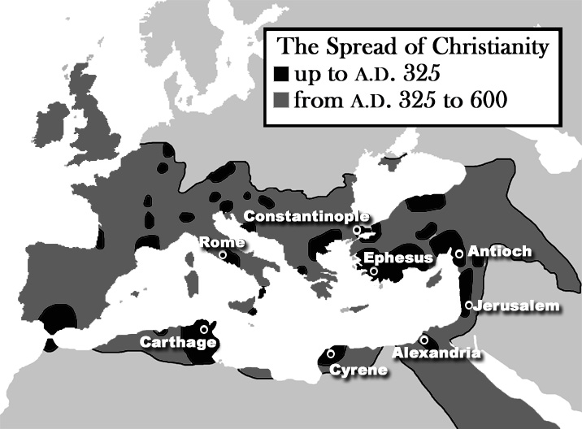
- To the Northwest (Europe)

- The book of Acts describes the initial spread of the gospel to Greece, Italy, and even mentions Spain. The gospel spread quickly into parts of modern-day France and Germany, and even reached Britain relatively early. (According to some traditions, the apostle Andrew is said to have first brought the gospel to Scotland.)

- The majority of this class will focus on the spread of Christianity into Europe, and eventually North America (next semester).

- To the Southwest (Africa)

- Acts 2 notes that Egyptians and Cyrenians were among the crowds at Pentecost, and Acts 8 explains that an Ethiopian Court official was converted under the ministry of Philip.

- In North Africa, Christianity flourished along the Mediterranean coast. The Christians there suffered severe persecution until a.d. 311, when Constantine issued the Edict of Milan.

- In Egypt, Christianity flourished until the rise of Islam in the seventh century. Alexandria became one of the most important centers of Christian thought. The main language was Coptic, which is why the church in Egypt became known as the Coptic Church.

- In Nubia (modern-day Sudan), Christianity was introduced by Christian monks and traders in the fifth and sixth centuries. As a result, the ruling class in Nubia eventually converted to Christianity.

- In Aksum (modern-day Ethiopia), the rulers converted to Christianity in the fourth century as a result of Christian traders who brought the gospel to that region. Of course, the gospel was probably first brought to Ethiopia in the first century by the court official mentioned in Acts 8.

- To the East (Asia)

- Christianity began in the Middle East and spread east from there.

- In Syria and Turkey, the church in Antioch was the first predominantly Gentile Church (Acts 11). The apostle Paul was from Tarsus, a city in modern-day Turkey.

- The church in Armenia was (according to tradition) founded by two of the apostles: Thaddaeus and Bartholomew between a.d. 40–60. Armenia officially adopted Christianity as its national religion in 301, making it the first Christian nation.

- Christianity was reportedly taken to Georgia (next to Armenia) by the apostles Simon and Andrew. It became the official religion in 327. (By contrast, Rome did not adopt Christianity as the state-religion until 380, under Theodosius I.)

- Christianity spread eastward into the Parthian Empire (modern-day Iraq and Iran), under the initial efforts of the apostle Thomas. It continued to grow there, such that the Christians of Mesopotamia and Iran sent bishops to the Council of Nicea in 325.

- Christianity also existed under the Sassanid Empire, which replaced the Parthian Empire, though believers were sometimes persecuted—in part because Christianity at that time was associated with political Roman state.

- The earliest known reference to Christian communities in Central Asia (modern-day Afghanistan and Pakistan) is from a writing by Bardaisan (a Gnostic) around 196, which mentions Christians in Bactria.

- Thomas is also reported to have taken Christianity to India, where the Indo-Parthian king Gondophares was converted and baptized.

- In 424, the church in Persia (the Assyrian Church) formally separated from the western Syrian Church which was under Roman (Byzantine) supervision.

- The Assyrian Church continued to expand east, and by 650 there were at least 20 Assyrian dioceses east of the Oxus river (which runs along the borders of Afghanistan and Pakistan).

- From around 498, there are records indicating that the Hephthalites (who inhabited modern-day Afghanistan and Pakistan) were somewhat receptive to Christianity.
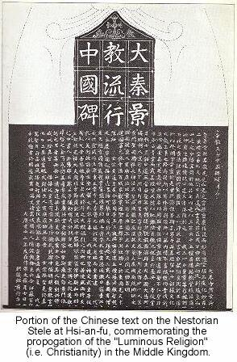
- Also, the Mongols were proselytized by Assyrian Christians beginning about the seventh century.

- Christianity is generally thought to have been introduced into China during the Tang Dynasty (which started in the early seventh century).

- However, there are indications that churches may have been established in China much earlier (perhaps the early 400s).

- A stone stele was discovered in China in the 1600s (see picture). It dates back to 781, and describes the fact that flourishing communities of Christians were present in the Tang dynasty in the 700s.

- Below is a map noting some of the regions (in Africa and Asia) that were influenced by Christianity in the early centuries of church history.

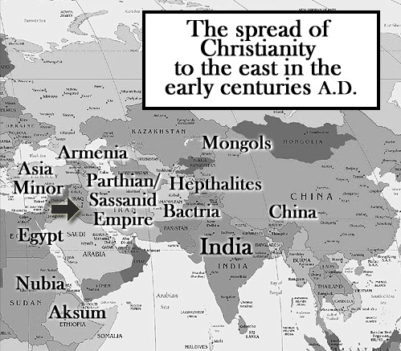

.

For Further Study:

- Because this class primarily focuses on the history of the church in the West, students who are interested in studying the history of the church in Africa or Asia may find the following resources helpful:

  - The Kingdom of God in Africa: A Short History of African Christianity (by Mark Shaw)

  - A History of Christianity in Africa: From Antiquity to the Present (by Elizabeth Isichei)

  - A History of Christianity in Asia, 2 volumes (by Samuel Moffett)

  - The Lost History of Christianity (by Philip Jenkins)

