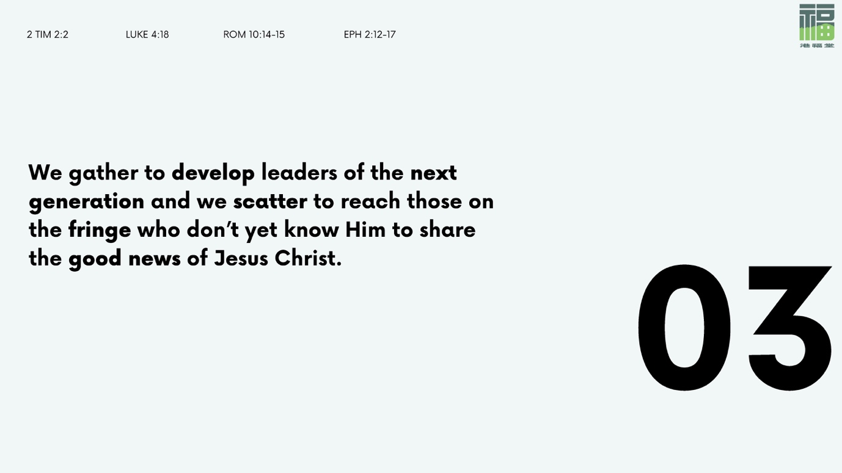

Who we were: In the beginning, God commissioned humanity to be fruitful, to fill the earth and subdue it (Gen. 1:28) God made humanity in His image, both male and female, and He saw that it was very good (Gen. 1:27, 31a).

Who we are: Because of the Fall, we all fall desperately short of the glory of God (Rom. 3:23) No one is worthy to dwell with God in the new heaven and earth (Rev. 21). But the good news is this—because of God the Father and His great love for us, we have Jesus Christ who was sent down to earth. Because of Jesus the Son and His worthy sacrifice for us, we now have the forgiveness of sins and God the Holy Spirit who dwells within us. Because of the Spirit’s transforming work in us, we are now being prepared to dwell with God, being built day by day with the rest of God’s people into a dwelling place for Him (Eph. 2:22).

Who we will be: We will be God’s people in the new Jerusalem, the new heaven and earth. The dwelling place of God will be with man; He will dwell with us. We will be His people. God Himself will be with us as our God (Rev. 21:3).

We scatter because we are headed towards the new heaven and earth, and yet there are people who have not yet heard the good news about the Lamb of God. We go, because we know what we have heard. We go, because we love our friends and family, and we want them to receive the gift that we have received.

It is true that by our own merit, we never could have access to the new Jerusalem. We are sinful, broken, and unclean. How could a perfect place allow imperfect people in without having its perfection be tainted and spoiled? But we go, because we know that God is wanting to invite as many of us as possible (Matt. 22:9). We go, because of God’s great love for us, a love that compelled Him to send His Son down to this earth, and a love that invites us to believe in Him and be saved. (Jn. 3:16-17)

- Other than being able to be with Jesus, what about the new heaven and the new earth are you most looking forward to?

- Take a moment to picture a group of Christ-followers embodying the Great Commission in their workplaces and other spheres of influence in our city.
What comes to mind?
What kind of new life / future in Christ do you think God is calling our city to experience, and how can you be part of that?

- In his book Mere Christianity, C.S. Lewis said this:

“If you read history you will find that the Christians who did most for the present world were just those who thought most of the next… It is since Christians have largely ceased to think of the other world that they have become so ineffective in this. Aim at Heaven and you will get earth “thrown in”: aim at earth and you will get neither.”

How often do you keep the end in mind? How might living with an eternal perspective change the way you currently live, and how can you more intentionally live in light of the eternal destiny we have as God’s people?

