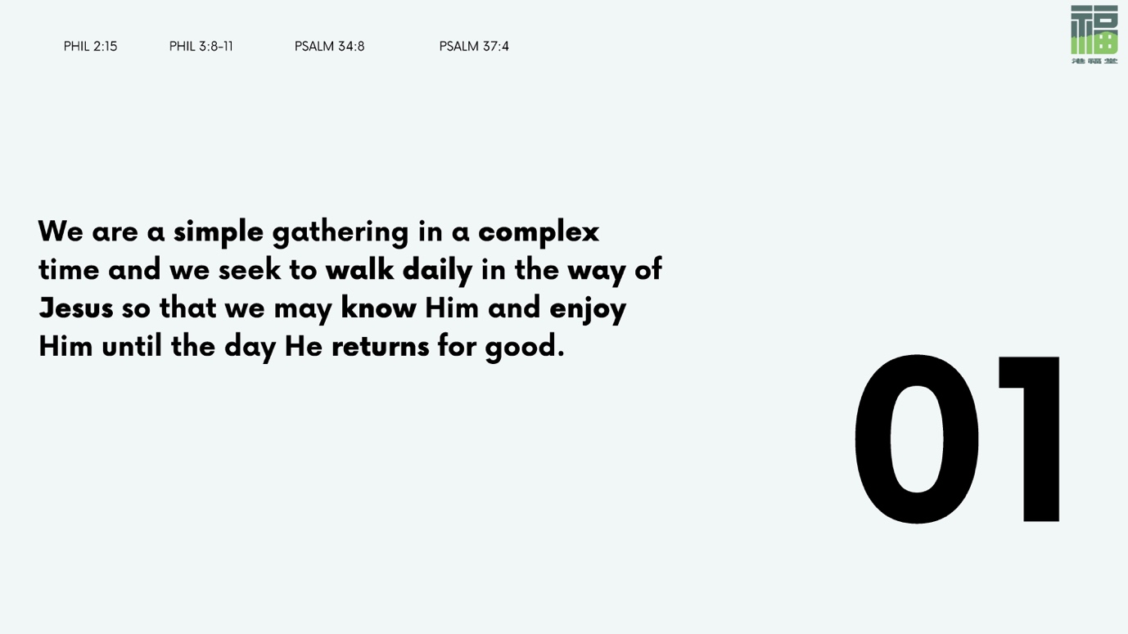

We are The Gathering. We are a simple assembly of Christ-followers in a complex time. We are people who are keen to seek and know Jesus, who are called to shine as lights in the world in the midst of a crooked and twisted generation (Phil. 2:15). Our name comes from the New Testament word for church, “ekklēsia”, meaning “gathering, assembly, congregation.” The “ekklēsia” referred to the actual gathering of people, not just the people themselves. When we are gathered together, we are the “ekklēsia”. We are the Church.

We gather because of our love for Jesus and His love for us. It prompts us to follow Him and to walk His way, so that we might know and enjoy Him until the day He returns for good (Ps. 34:8). The Jesus way is not a rushed, frenetic scramble. It is a purposeful and intentional journey done daily. It requires patience from us to walk in humility, but gives to us peace. It teaches us to be unrushed, unstressed, and unhurried as we live life trusting in God’s good timing and do life according to His free-flow rhythms of grace. We share in the power of Jesus as we become more and more like Him, seeking to walk in step with His Spirit and the good work He is doing within us.

We follow in the footsteps of the early church (Acts 2:42) by seeking to know Jesus through reading His Word, which is His message to us. We converse with Him in prayer, and wait to hear how He responds. We surround ourselves with people who know and enjoy Him. We make Him and His people a priority in our lives. We do not do this arbitrarily but with an eye to eternity, knowing that we need each other as we wait for the day He returns for good (Heb. 10:24).

- Psalm 139 says that we are “fearfully and wonderfully made” (v.14). The Lord crafted us with such deliberation as to make every one of us unique, and we may each have our own special way of relating to and connecting with God.
Share now with your group the conventional and unconventional ways that you relate to God. Don’t be afraid to take inspiration from one another in seeking and trying out creative or different ways of enjoying God’s presence!

- As we seek to walk daily in the way of Jesus so that we may know Him and enjoy Him, we will find ourselves becoming more and more like Him.

Go through the passage of Galatians 5:16-26 together as a group, and identify the qualities which belong to the old nature of the flesh and those of the new nature given to us by Christ Jesus.

Take some time individually to reflect on the old nature that remains within, but do not stop there. Ask the Holy Spirit if there is anything holding you back from the fruit that God wants to grow in your life, and how you might continue to keep in step with Him in all the areas of your life.

- In Hebrews 10:24-25, the writer encourages his readers to “consider how to stir up one another to love and good works, not neglecting to meet together…but encouraging one another, and all the more as [we] see the Day drawing near.”

Have the members of your group each write a letter of encouragement to one person within your group now, as you “consider how to stir up one another to love and good works” in light of the Day drawing near. It might be a letter of encouragement about the fruit that you see in their lives, the measure of Christlikeness that you see them reflect, or a heartfelt prayer for them as they might currently be going through tough times in life.

