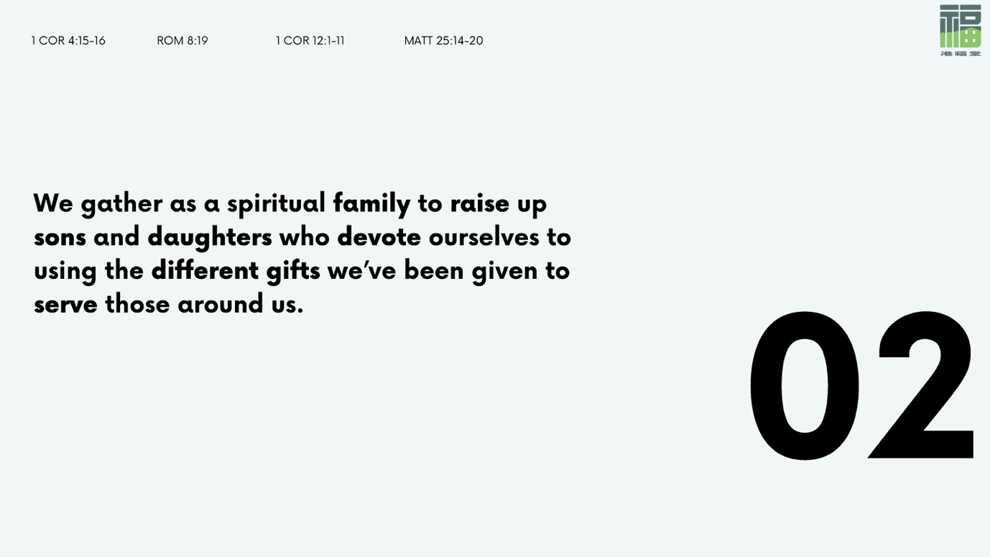

Cain’s murder of Abel. Lot and his daughters. Isaac’s favoritism of Esau over Jacob, and Jacob’s favoritism of Joseph and Benjamin over their brothers. The breakdown of the family unit may seem like a modern-day phenomenon, but the Scriptures confront us with the truth of human brokenness and sin.

It is unfortunate, because God’s original intention was for the family unit to be a place of refuge, of safety and support. But because of human brokenness and sin, generational cycles of hurt and dysfunctionality are passed on. Hurt people continue to hurt other people—both within and without the family.

Perhaps that is why the apostle Paul stresses and emphasizes the radical concept of the family of God. He takes something that we are familiar with—our family—and turns it on its head, all because of Christ. Because Christ so loved us and died for us, we who were strangers are now adopted into God’s family and able to call ourselves brothers and sisters, children of God (1 Jn. 3:1-2). Because He first loved us, we are now commanded to love one another (Jn. 13:34-35).

Being family means developing close-knit relationships with one another. It is not enough to have someone act as a guide or coach in your life (1 Cor. 4:15). What the church needs is spiritual fathers and mothers who are ready and willing to raise up spiritual sons and daughters. People who are ready to teach, model, and impart the love of Christ to others growing in their capability to receive and impart that love themselves, all because Christ first loved us.

God’s heart is one of justice and redemption to the poor, the lost, the broken, and the needy. That includes those who have suffered the consequences of family breakdown. Let us rise up and be spiritual fathers and mothers, sons and daughters who are ready to receive and respond to Christ’s love for us. Let us be family to one another, with all of its messiness and brokenness, but in the midst of it all find redemption from God’s love and heal.

- What sort of learning, teaching, mentoring, or discipling did you receive from church or elsewhere when you first became a Christ-follower? Was there any teaching in particular that was very influential in your life, and that served as a foundation for your understanding of the faith?

- As a group, go through the discipleship tree together.
Some questions to ask might be:
  - Who are the people who are pouring into your life? What does it look like to be poured into by them? If there is no one who is pouring into you, who might God be calling you to reach out to and invite into your life?
  - Are there people you are walking with? What does it look like to be walking with them? If not, why is that the case, and might there be someone that God is calling you to get alongside and support?
  - If you are walking with someone, are these people pouring into other people themselves? If not, is there anything you can do to equip and encourage them to do so?
  - Would you say that there is a culture of intentional discipleship within The Gathering? How might we as a church grow in our discipleship of others, and continue to equip people to share their faith and be disciples and disciple-makers in our day-to-day lives with our colleagues, family, and friends?

- Take some time now to break into smaller groups of three to four, and pray over the people who are pouring into your life, and those who you are pouring into. Pray over yourself as well, that you would be full of gratitude and humility over the work that God is doing in your life.
If you do not yet feel ready or do not have someone who is pouring into you and vice versa, ask the Holy Spirit to show you areas in your life where you might need to grow and heal, such that you are able to invite others into your faith journey, and walk with others as well.
Pray as well that the Spirit would lead and guide you to someone as you become increasingly ready, or encourage you to take that leap of faith where it is needed.

