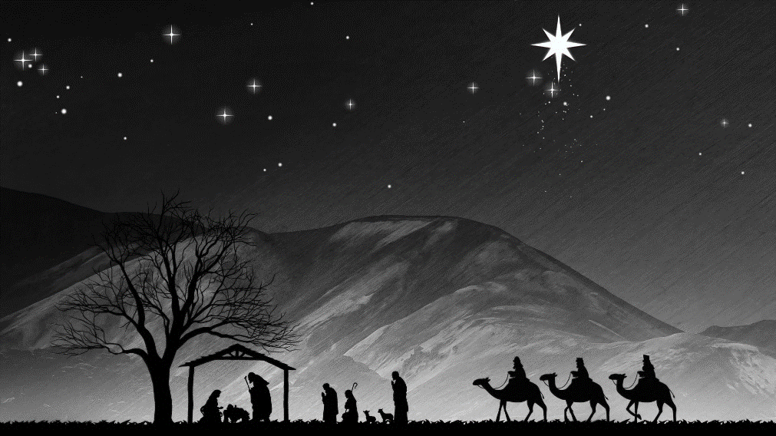

**Christmas Day Service 2019**

BEM Kuching Evangelical Church

9.00 am

**CHRISTMAS DAY ORDER OF SERVICE 2019**

**Opening animation: HappyLand Nativity**

**Song: Joy to the World**

**Song: Angels we have heard on high**

**Old Testament Bible Reading** (Alveen Yeo)

Isaiah 11:1-10

Zephaniah 3:14-17

**Song: O come all ye faithful**

**Song: For unto us a child is born**

**New Testament Bible Reading** (Ganit Libat)

Matthew 1:18-2:12

**Prayers** (Dr. Ng Hoong Phak)

**Video: Light in the Darkness**

**New Testament Bible Reading** (Joshua Jordan Silas)

Galatians 4:4-7

**4**But when the set time had fully come, God sent his Son, born of a woman, born under the law, **5**to redeem those under the law, that we might receive adoption to sonship. **6**Because you are his sons, God sent the Spirit of his Son into our hearts, the Spirit who calls out, *“Abba*, Father.” **7**So you are no longer a slave, but God’s child; and since you are his child, God has made you also an heir.

**Talk: Dear God, what is Christmas really all about?**

For some, Christmas is about…

* Earning
* Parading
* “Jesus”-ing

From today’s passage, Christmas in one word: ________________

**The Son of God became man… (v.4-5a)**

Father

Son

Relational

Enslaved – our loves go wrong

God stepped in…to redeem

**…so that men can become sons of God (v.5b-7)**

Heirs

Another gift

* You are accepted
* You are loved
* You can change

**Response song: Hark, the herald angels sing!**