How should a Christian engage with the World?

A complex topic

Some texts: John 15:18-19; 1 Jn 2:15-17; John 3:16

- What is the world?

- A pattern in the Bible:

Israel amongst the nations/Christians in the world

Two dangers: opposition and attraction

- We are in the world…how to respond?
NO!

YES!

maybe…

different seasons, different responses?

We are children of the word in the midst of the world…

- Facing opposition

The big danger

The big responsibility

- Resisting Attraction

Do not love the world or the things of the world

What we see, what we want, what we need

A question of loves

- The world needs us

To testify

To be different

So, engage to the extent you can in your circumstances

- What’s in your world?

Opposition?


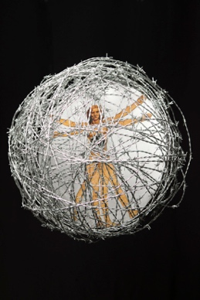
Attraction?

