4 Keys to Effective Ministry to Young People (Part 2)

What you are doing is important

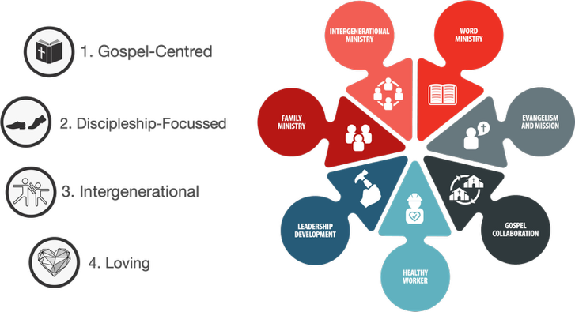
Ephesians 6:1-4

Catchup on Part 1

- Intergenerational

Some common ideas

Gospel Centred Ministry to Young People

3 points

Discussion (what are we doing/what could we do?)

- Loving

Some common ideas…

Loving ministry to young people

3 Points

Discussion (what are we doing/what could we do?)

